Exercise –

01 –

Upload the 1D_Convolution.ipynb notebook to colab. Run all cells (Runtime->Run all). Can you explain what you observe as the output? Can you explain the reason for getting that output? Based on the output, can you explain how it’s possible to detect the edges of an image using the Convolution operator?

Programming –

1. Import Libraries –

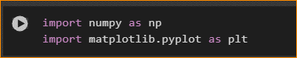

Use numpy and matplotlib

1. 1D convolution – Basic Signal



1. Plot the Graph



Result is like this –

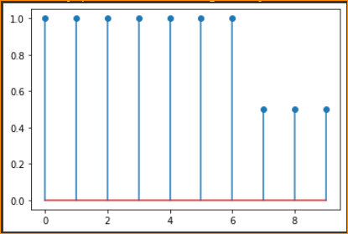

Note – matplotlib.pyplot.stem

Stem Plot

* stem plots vertical lines from a baseline to the y-coordinate and places a marker at the tip.

Example –

**import** **matplotlib.pyplot** **as** **plt**

**import** **numpy** **as** **np**

[x](https://docs.scipy.org/doc/numpy/reference/generated/numpy.ndarray.html#numpy.ndarray) = [np.linspace](https://docs.scipy.org/doc/numpy/reference/generated/numpy.linspace.html#numpy.linspace)(0.1, 2 * [np.pi](https://docs.scipy.org/doc/numpy/reference/constants.html#numpy.pi), 41)

[y](https://docs.scipy.org/doc/numpy/reference/generated/numpy.ndarray.html#numpy.ndarray) = [np.exp](https://docs.scipy.org/doc/numpy/reference/generated/numpy.exp.html#numpy.exp)([np.sin](https://docs.scipy.org/doc/numpy/reference/generated/numpy.sin.html" \l "numpy.sin" \o "View documentation for numpy.sin)([x](https://docs.scipy.org/doc/numpy/reference/generated/numpy.ndarray.html#numpy.ndarray)))

[plt.stem](https://matplotlib.org/3.1.1/api/_as_gen/matplotlib.pyplot.stem.html#matplotlib.pyplot.stem)([x](https://docs.scipy.org/doc/numpy/reference/generated/numpy.ndarray.html#numpy.ndarray), [y](https://docs.scipy.org/doc/numpy/reference/generated/numpy.ndarray.html#numpy.ndarray), use_line_collection=**True**)

[plt.show](https://matplotlib.org/3.1.1/api/_as_gen/matplotlib.pyplot.show.html#matplotlib.pyplot.show)()

result –

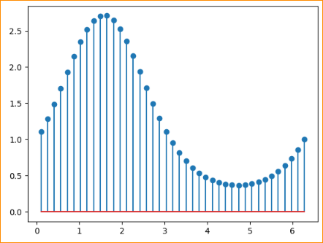

1. Convolution Filter – Use the convolution operation



numpy.convolve(a, v, mode='full')

**Returns the discrete, linear convolution of two one-dimensional sequences.**

The convolution operator is often seen in signal processing, where it models the effect of a linear time-invariant system on a signal [1]. In probability theory, the sum of two independent random variables is distributed according to the convolution of their individual distributions.

* In we got the result and Result going to plot like this –

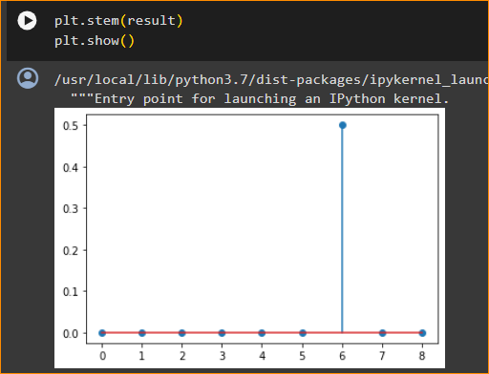

1. Now change the input array to 1, 1, 1, 0.5, 0.5, 1, 1, 0.5, 0.5, 0.5.

Run the notebook again using the ‘Run all’ menu item. What can you say about the new output?

So the result is like this -

